APPOINTMENT SCHEDULER
@CREATIVITY THINK (9483175986/7019689991)

ABSTRACT:
The Appointment Scheduler is a web-based platform designed to streamline appointment booking and management for doctors, clinics, salons, and service providers. Users can register, book available slots, receive confirmation and reminder notifications, attend appointments, and provide feedback. Administrators manage appointment slots, edit bookings, review feedback, send reminders, and analyze peak usage through a comprehensive dashboard. Built with Django and Django Rest Framework for backend operations and React with React-Calendar for the frontend, the system ensures secure, real-time scheduling and analytics. The platform improves efficiency, reduces missed appointments, and enhances user and administrator experience..

INTRODUCTION OF THE PROJECT:
Efficient appointment management is essential for service providers to reduce wait times and optimize resource utilization. The Appointment Scheduler provides users with tools to book available slots, receive notifications, and submit feedback, while administrators manage schedules, bookings, feedback, and peak usage analytics. Leveraging Django for backend operations and React with React-Calendar for the frontend interface, the system ensures secure, scalable, and real-time scheduling. The platform benefits clinics, salons, repair shops, and other service-oriented businesses by enhancing convenience, user satisfaction, and operational efficiency..

PROJECT OBJECTIVES:

• Develop a centralized platform for appointment scheduling
• Enable users to book available slots and receive confirmations
• Provide notifications and reminders for upcoming appointments
• Allow admins to manage slots, bookings, and user feedback
• Analyze peak usage patterns and optimize scheduling
• Collect user feedback and ratings for service improvement
• Improve efficiency and reduce missed appointments

PROBLEM OF THE STATEMENT:
Manual appointment scheduling often leads to double bookings, missed appointments, inefficient resource allocation, and poor user experience. Users may forget appointments due to lack of reminders, and administrators struggle with managing multiple slots and analyzing peak usage. The Appointment Scheduler addresses these challenges by providing a centralized platform where users can book, receive reminders, and provide feedback, while administrators manage slots, bookings, and analytics efficiently. This ensures optimal scheduling, improved user satisfaction, and enhanced operational efficiency for service providers..

MOTIVATION OF THE PROJECT:
• Streamline appointment booking and management
• Reduce missed appointments with reminder notifications
• Provide administrators with peak usage analytics
• Collect user feedback to improve services
• Centralize scheduling for users and service providers

BLOCK DAIGRAM OF PROJECT:

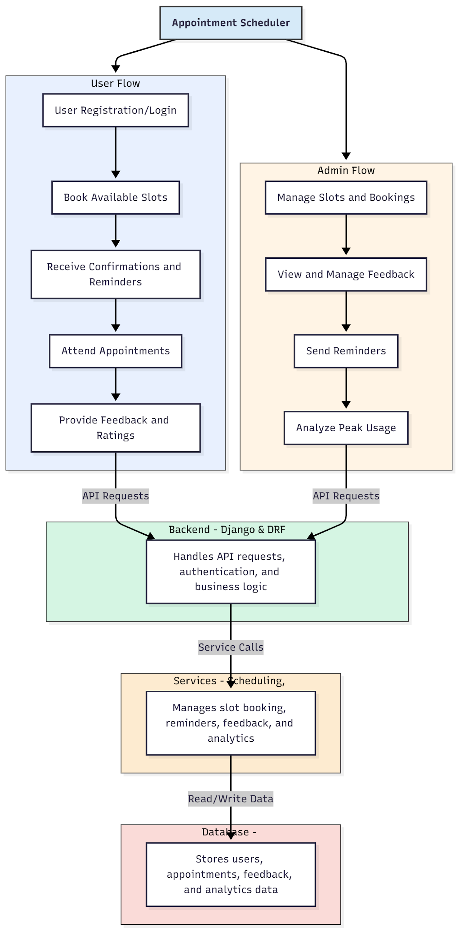

WORKING OF THE PROJECT:
Users register or log in to the Appointment Scheduler, browse available slots, and book appointments. Confirmations and reminder notifications ensure timely attendance. Users can provide feedback and ratings post-appointment. The backend handles API requests, authentication, and business logic, while services manage scheduling, notifications, feedback, and analytics. Administrators manage slots and bookings, review user feedback, send reminders, and analyze peak usage for optimized scheduling. The integrated system ensures smooth, efficient, and centralized appointment management for users and administrators..

SOFTWARE REQUIREMENT:
- Backend:
  - Python 3.x
  - Django
  - Django REST Framework
  - SQLite/PostgreSQL
- Frontend:
  - Node.js and npm
  - React.js
  - Axios
- Development Tools:
  - Visual Studio Code
  - Postman (for testing APIs)
  - Git/GitHub (for version control)
- Server/Deployment (Optional):
  - Gunicorn, Nginx, or Heroku/AWS for hosting

ADVANTAGES OF THE PROJECT:

• Centralized appointment scheduling
• Real-time notifications and reminders
• Admin dashboard for managing slots and bookings
• Analytics for peak usage and scheduling optimization
• User feedback collection for service improvement
• Reduces missed appointments and delays
• Improves user satisfaction and experience
• Efficient management for service providers

APPLICATIONS OF THE PROJECT:
• Doctors and clinics for appointment management
• Salons and beauty service providers
• Repair shops and service centers
• Personal trainers and fitness consultations
• Counseling and therapy session scheduling
• Event or meeting booking systems
• Online consultation services
• Any business requiring efficient scheduling and reminders

REFERENCES:

- Django REST Framework Documentation — Django Software Foundation. Django Documentation. Available: https://docs.djangoproject.com/
- Django REST Framework. DRF Documentation. Available: https://www.django-rest-framework.org/
- React. React Official Documentation. Available: https://reactjs.org/docs/getting-started.html
- Redux. Redux Documentation. Available: https://redux.js.org/introduction/getting-started
- PostgreSQL Global Development Group. PostgreSQL Documentation. Available: https://www.postgresql.org/docs/
- MySQL. MySQL Reference Manual. Available: https://dev.mysql.com/doc/
- Git. Git Documentation. Available: https://git-scm.com/doc
- Node.js. Node.js Documentation. Available: https://nodejs.org/en/docs/
- Axios. Axios Documentation. Available: https://axios-http.com/docs/intro
- Socket.io Documentation – https://socket.io/docs/

